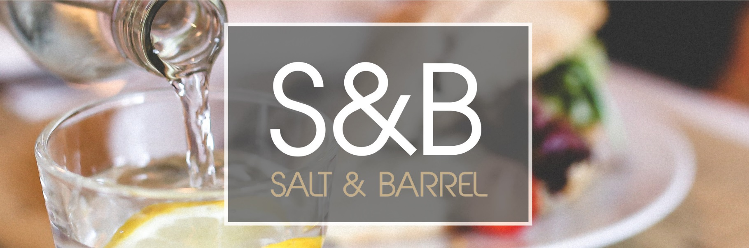

**White Wine 125ml/175ml Per Bottle ABV**

**Via Nova Pinot Grigio £3.00/£4.20 £14.50 11.5%**

**Italy**

Light and fruity dry wine, with ripe citrus characters

and hints of hazelnut on the finish

**Vinamar Sauvignon Blanc £3.00/£4.20 £14.50 13%**

**Chile**

Intense aromas of pineapple and mango with soft herbal notes

**Red Wine**

**Homeward Bound Shiraz £3.00/£4.20 £14.50 13.5%**

**Australia**

A gorgeous full-bodied wine with lashings of blueberry and plum.

**Longue Roche Merlot £3.00/£4.20 £14.50 14.5%**

**France**

A soft and elegant red wine with ripe damson fruit

character, subtle tannin and a long finish.

**Rose Wine**

**Anciens Temps £3.00/£4.20 £14.50 12%**

**Vin de France**

With an attractive pale pink colour, this is a light and refreshing rosé

accompanied by aromas of strawberry and blackcurrant.

**Sparkling Wine**

**Trulli – Prosecco 200ml bottle £4.75 11 %**

**Italy**

Packed with soft fruit flavours, hints of peachy fruit

and a long lingering finish

**Tosti – Prosecco 750ml bottle £16.00 11%**

**Italy**

Extra dry, fruity with hints of fresh apple

**Non-Alcoholic Wine**

**Artis Chardonnay £2.20/£3.00 <0.5 %**

**France**

Floral and fruity taste profile

**Artis Merlot £2.20/£3.00 <0.5 %**

**France**

Round and fruity taste profile



**Spirits – 25ml £ ABV**

Vodka – Belvedere £2.20 40 %

Gin – Tanqueray £2.20 43.1%

Whisky – Johnnie Walker – Black Label £2.20 40 %

Rum – Bacardi Carta Blanca £2.20 37.5 %

Brandy – Janneau £2.20 40 %

**Port – 50ml**

Cockburns

£3.00 20 %

**Bottled Cider – 500ml bottle**

Kopparberg Mixed Fruit

**Draught Beer**

Birra Moretti – ½ pint £2.00 4.6 %

Birra Moretti – pint £4.00 4.6 %

**Bottled Beer – 330ml bottle**

Peroni £2.80 5.1 %

Birra Moretti

£2.80 5.1 %

**Non-alcoholic Beer – 500ml bottle**

Beck’s Blue £2.50 <0.5 %

**Soft Drinks**

Coca Cola / Diet Coca Cola - 330ml bottle £1.20

Appletiser - 275ml bottle £1.20

Irn Bru / Diet Irn Bru 330ml bottle £1.20

Fresh Apple / Orange Juice/ Cranberry Juice £1.00

Diluting Squash – (Orange / Blackcurrant) £0.50

Fever-Tree Tonic Water- 200ml bottle £1.20

Fever-Tree/Britvic Ginger beer- 200ml bottle £1.20

Fever-Tree Soda Water – 200ml bottle £1.20

Fever-Tree Sicilian Lemonade – 200ml bottle £1.20

Dash of Cordial (Orange/Blackcurrant/Lime) £0.20

**Water**

Sparkling – 330ml bottle £1.00

Sparkling – 1 litre bottle £2.20

***The Salt and Barrel reserve the right to refuse sale to guests who are still to attend classes, Ayrshire college works under a zero tolerance policy.***

Mocktails and Cocktails

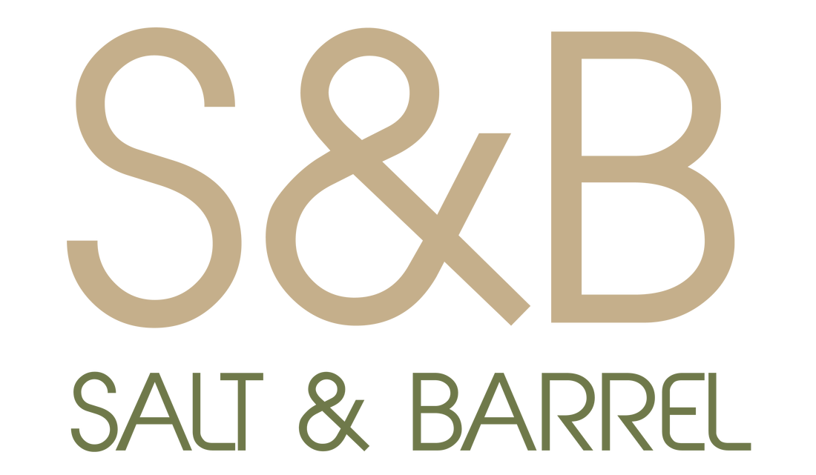

See Specials board

For details.